**EXPERIMENT 12**

**CURSORS**

**Aim:**

* Create a table with attributes students and marks.
* Insert values into the table.
* Create a procedure, and fetch the marks of given id using a cursor.

**create table cur(id int, marks int);**

**insert into cur(id,marks) values(1,30),(2,40),(3,50),(5,60);**

**DELIMITER //**

**create procedure cur_mark(id1 int)**

**begin**

**declare m1 int;**

**declare cur1 cursor for select marks from cur where id=id1;**

**open cur1;**

**fetch cur1 into m1;**

**select m1;**

**close cur1;**

**end //**

**delimiter ;**

**call cur_mark(2);**

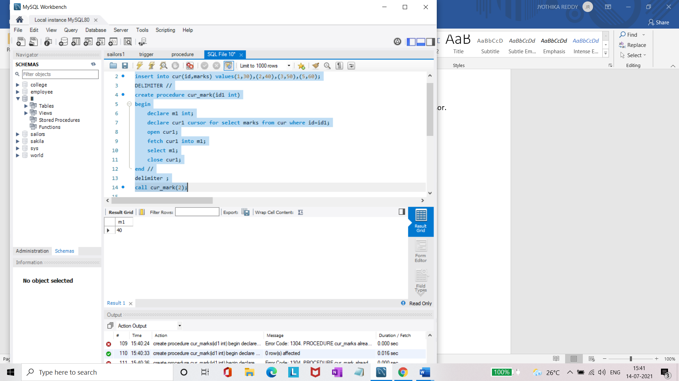

* Create a procedure, and fetch the highest marks using a cursor.

**DELIMITER //**

**create procedure cur_max_marks(out idd int)**

**begin**

**declare m1 int;**

**declare cur1 cursor for select max(marks) from cur as max;**

**open cur1;**

**fetch cur1 into m1;**

**select m1;**

**close cur1;**

**end //**

**delimiter ;**

**call cur_max_marks(@idd);**

